Check first:
lsb_release -a
If it says Ubuntu 26.04, continue below.
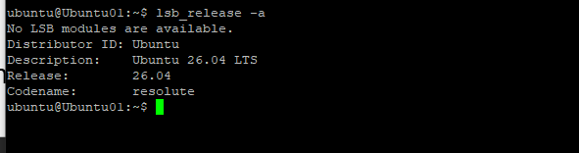

STEP 1 Become rootOn your Ubuntu Server, type:
sudo -su
You'll now see something like:
root@ubuntu:~#

What just happened?
You are telling Ubuntu:
"I want administrator/root privileges because I'm installing system software."

STEP 2 Install the Zabbix repository
First download Zabbix's repository package:
wget https://repo.zabbix.com/zabbix/7.4/release/ubuntu/pool/main/z/zabbix-release/zabbix-release_7.4-4+ubuntu26.04_all.deb
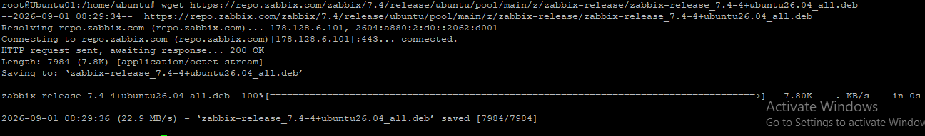
Then install it:
Then:
dpkg -i zabbix-release_7.4-4+ubuntu26.04_all.deb
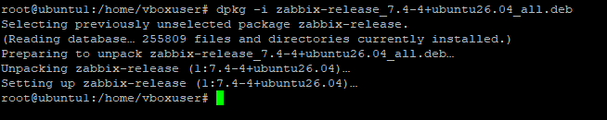

Step 2 — Configure Zabbix 7.4 repository
The original repository filename produced a 404 Not Found, so we corrected it and installed the current repository package.
Then:
apt update

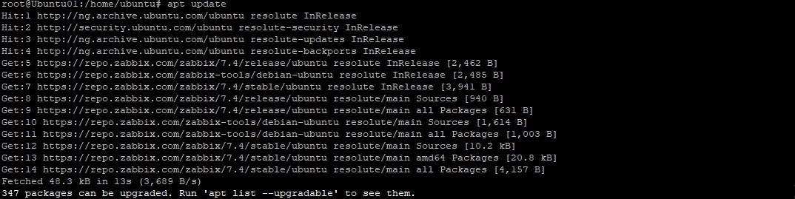

STEP 3 — Install Zabbix
Now install the Zabbix components:
apt install zabbix-server-mysql zabbix-frontend-php zabbix-apache-conf zabbix-sql-scripts zabbix-agent

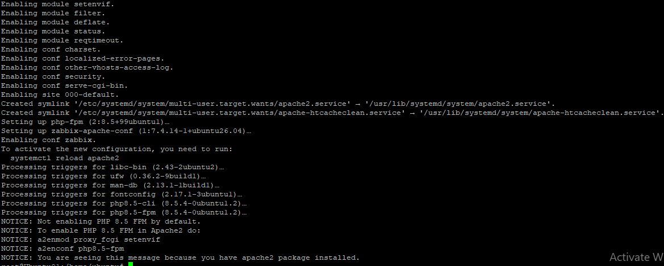
Check it:
dpkg -l | grep zabbix

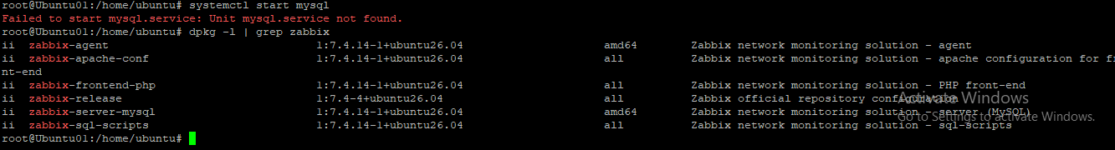

STEP 4 — Install MySQL Server

Since you're already root, run:
apt install mysql-server

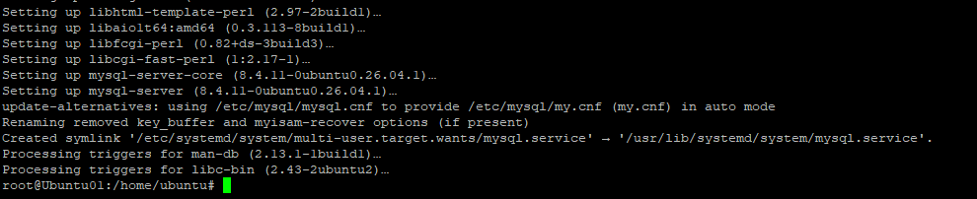

After the installation finishes, run:
systemctl start mysql
And make it start automatically:
systemctl enable mysql
Check it:
systemctl status mysql
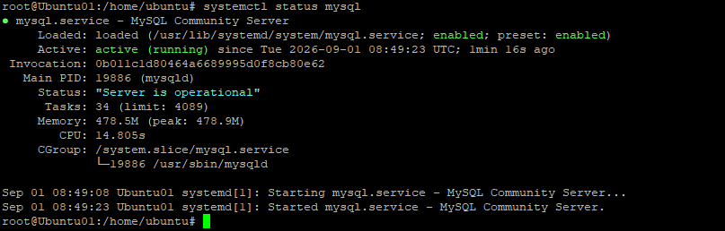

STEP 5 Create the Zabbix database
Now type:
mysql -u root -p
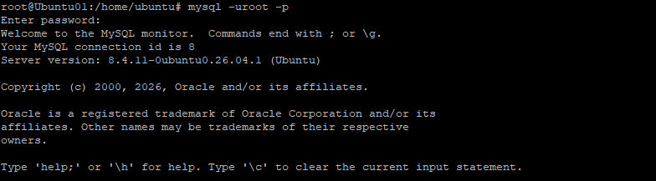
It will ask:
Enter password:
If your MySQL root account doesn't have a password and the command doesn't let you in, tell me what error you get rather than guessing.
Once you're inside MySQL, you'll see:
mysql>
Now run:
create database zabbix character set utf8mb4 collate utf8mb4_bin;
Press Enter.
Then create the Zabbix database user:
create user zabbix@localhost identified by 'User$2026';

Example
You could use:
create user zabbix@localhost identified by 'Zabbix@12345';
Then:
grant all privileges on zabbix.* to zabbix@localhost;
Then:
set global log_bin_trust_function_creators = 1;
Finally:
quit;
Now you're back at Ubuntu:
root@ubuntu:~#

STEP 6 Import the Zabbix database
This is an important step.
Run:
zcat /usr/share/zabbix/sql-scripts/mysql/server.sql.gz | mysql --default-character-set=utf8mb4 -uzabbix -p zabbix
It will ask for:
Enter password:User$2026

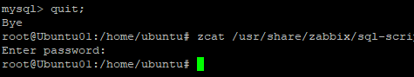

STEP 7 — Turn off the temporary database setting
Go back into MySQL:
mysql -uroot -p
Enter your MySQL root password.
Then:
set global log_bin_trust_function_creators = 0;
Then:
quit;

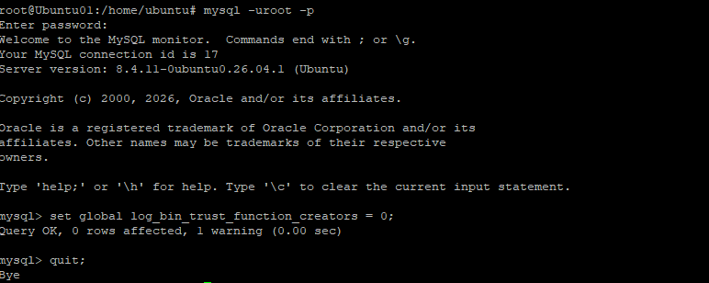

STEP 8 : Zabbix the database password
Now we need to tell Zabbix:
"The database password is this."
Open the configuration file:
nano /etc/zabbix/zabbix_server.conf
Find:
DBPassword=
Change it to:
DBPassword=User$2026
Use the password you actually created.

Save the file
Press:
CTRL + O
Press:
ENTER
Then:
CTRL + X

STEP 9 Enable Apache modules
Run:
a2enmod proxy
Then:
a2enmod proxy_fcgi
These allow Apache to properly communicate with the Zabbix web frontend/PHP.

STEP 10 Start Zabbix
Now we're getting close.
Run:
systemctl restart zabbix-server zabbix-agent apache2 php8.5-fpm
Run:
systemctl is-active zabbix-server zabbix-agent apache2
Then run to check the status of the zabbix server:

STEP 11 Check that Zabbix is running
Run:
systemctl status zabbix-server
Then:
systemctl status zabbix-agent
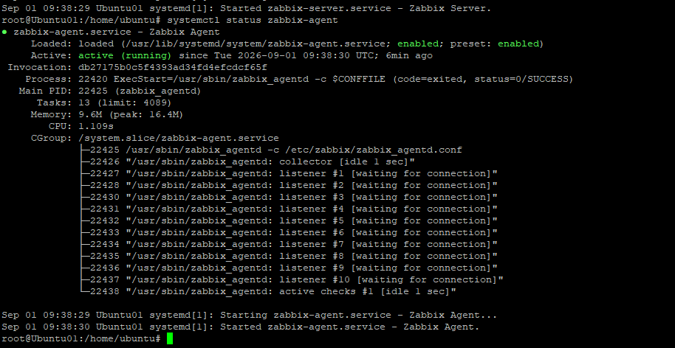

STEP 12 Find your Ubuntu IP address
Run:
ip addr
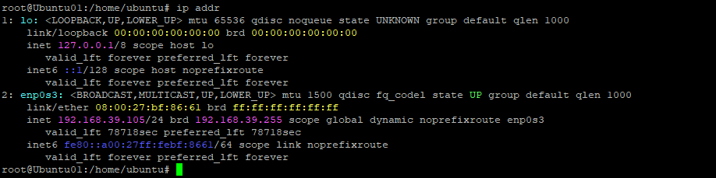

STEP 13 Open Zabbix from your Windows computer
On your Windows PC, open Chrome/Edge.
Enter:
http://192.168.39.105/zabbix
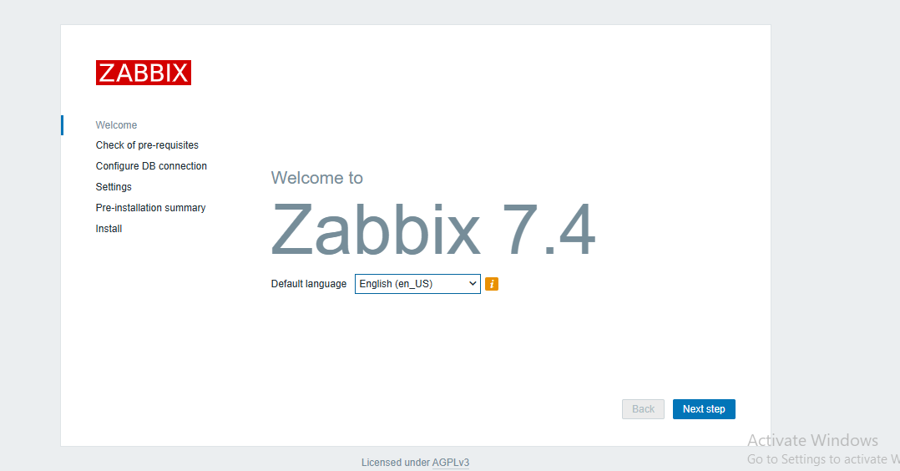
You should see the Zabbix web setup/login page.

STEP 15 Complete the web setup
You'll see the Zabbix frontend setup.
It will check things like:
PHP version OK
PHP extensions OK
Database OK
Apache OK
Then you'll enter your database information.
Use:
Database type: MySQL
Database host: localhost
Database name: zabbix
Database user: zabbix
Database password: User$2026
For example:
Database type: MySQL
Database host: localhost
Database name: zabbix
Database user: zabbix
Database password: User$2026

STEP 16 Finish installation
Zabbix will ask for some basic settings such as:
Zabbix server name
Timezone
You can call your server:
Zabbix-Monitoring
Choose your correct timezone.
Then continue.

STEP 17 Login
You'll eventually reach the Zabbix login screen.
For a standard Zabbix installation, the initial credentials are:
Username: Admin
Password: zabbix

